Strategy pattern is used when we have multiple algorithm for a specific task and client decides the actual implementation to be used at runtime.
http://www.journaldev.com/1754/strategy-design-pattern-in-java-example-tutorial
defines a family of algorithms,
- encapsulates each algorithm, and
- makes the algorithms interchangeable within that family.

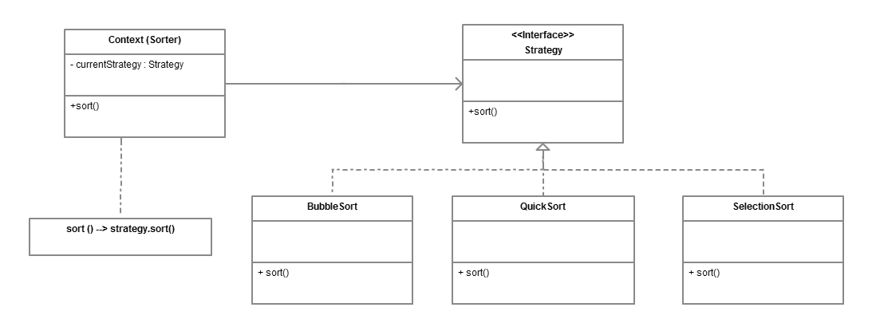

Ex: Define Strategy interface.
Define multiple implementing classes. It will not have instance variables. Only algorithm (behaviour).
When a behaviour is needed pass interface

